FIRST LEGO LEAGUE
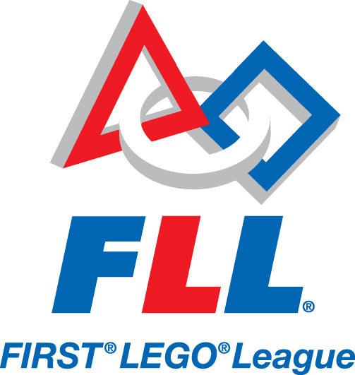
2020 Application
Clear Creek Elementary

Part 1. Parents: Fill out this portion of the application.

- Student Name: ___________________________________________________________

- Student’s age in the 2020-2021 School Year: ________Current Teacher_______________

- What is the student’s availability from August to December in 2020?

Monday 4:00 – 5:15 p.m. _______
Tuesday 4:00 – 5:00 p.m. _______
Wednesday 4:00 – 5:15 p.m. _______
Thursday 4:00 – 5:00 p.m. _______
Saturday morning 9-11 _______

- What is your child’s shirt size?

Youth XS Youth S Youth M Youth L Youth XL

Adult XS Adult S Adult M Adult L Adult XL

- Parent(s)/Guardian(s) Name(s)_______________________________________________
________________________________________________________________________
- Parent(s)/Guardian(s) Number(s)_____________________________________________
________________________________________________________________________
- Parent(s)/Guardian(s) Email(s) _______________________________________________
________________________________________________________________________
- Are you able to help your child with research at home for at least 1 hour each week?
Yes_____ No_____
- Are you able to attend any weekly meetings? If so, please place a check by the time.
Monday 4:00 – 5:15 p.m. _______ Wednesday 4:00 – 5:15 p.m. _______
Tuesday 4:00 – 5:00 p.m. _______ Thursday 4:00 – 5:00 p.m. _______
Saturday morning 9:00-11 _______

Parents will also be asked to attend events/tournaments and send an after-school snack with their child to each meeting.

Part 2. Students: Fill out this portion of the application. Include additional pages if needed. This may be handwritten or typed separately and returned to Mr.Whalen.

- Student Name ________________________________________________________________________

- Have you previously been involved in FIRST LEGO League or have you had experience with LEGO MINDSTORMS programming through camp or other educational classes? (If yes, please describe.)

______________________________________________________________________________________________________________________________________________________________________________
Read the information and/or watch the videos at the following links, then answer the following questions.
- What is FIRST LEGO League? https://www.youtube.com/watch?v=9qeBFeFyYp0
- Hydrodynamics Robot Game Overview: https://www.youtube.com/watch?time_continue=58&v=G35CsFVKSjY
- City Shaper (last season) https://www.youtube.com/watch?v=y_mTQZQ8Kzc&feature=youtu.be

- Why do you want to be involved in LEGO League at Clear Creek?

_____________________________________________________________________________________________________________________________________________________________________________________________________________________________________________________________________
- What are the eight FLL Core Values?
____________________________________________________________________________________________________________________________________________________________________________________________________________________________________________________________________________________________________________________________________________________________
- What strengths do you have that would help your team be successful?
____________________________________________________________________________________________________________________________________________________________________________________________________________________________________________________________________________________________________________________________________________________________

- What team conflict have you had in the past, and how did you help to resolve it?
___________________________________________________________________________________________________________________________________________________________________________________________________________________________________________________________________________________________________________________________________________________________________________________________________________________________________________________

- Last year’s theme was “City Shaper.” Which mission would you have chosen to work on first? Why? How?
____________________________________________________________________________________________________________________________________________________________________________________________________________________________________________________________________________________________________________________________________________________________
- Each year, FIRST LEGO League chooses a theme that addresses a problem in our world. Contestants work together to create innovative solutions to that problem. State one problem that you see in our world. Provide two innovative solutions that you see fit for this problem.

___________________________________________________________________________________________________________________________________________________________________________________________________________________________________________________________________________________________________________________________________________________________________________________________________________________________________________________
___________________________________________________________________________________________________________________________________________________________________________________________________________________________________________________________________________________________________________________________________________________________________________________________________________________________________________________

